**Assignment 1**

**Name:** PAMARTHI LAKSHMI DURGA

**Roll no:** 23485A5410

**Branch:** Artificial Intelligence & Data Science

**College Name:** Seshadri Rao Gudlavalleru Engineering College

**Bar chart**

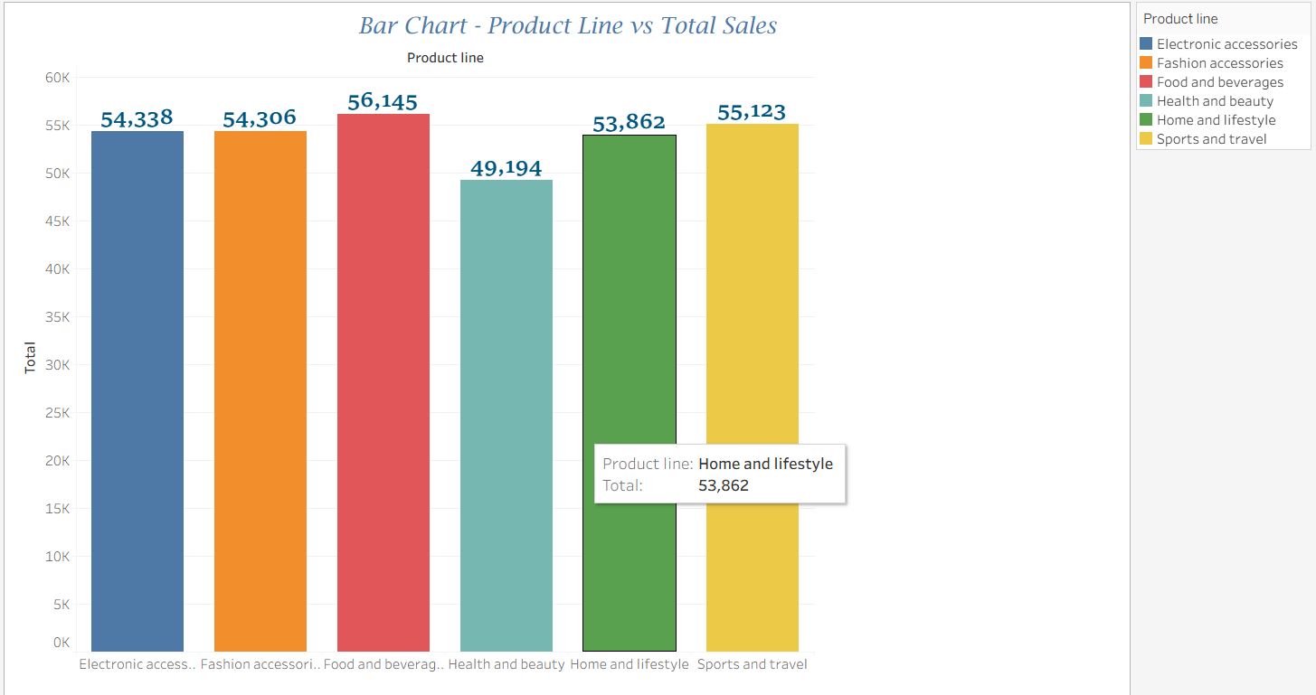

**Pie Chart-Sales by Payment**

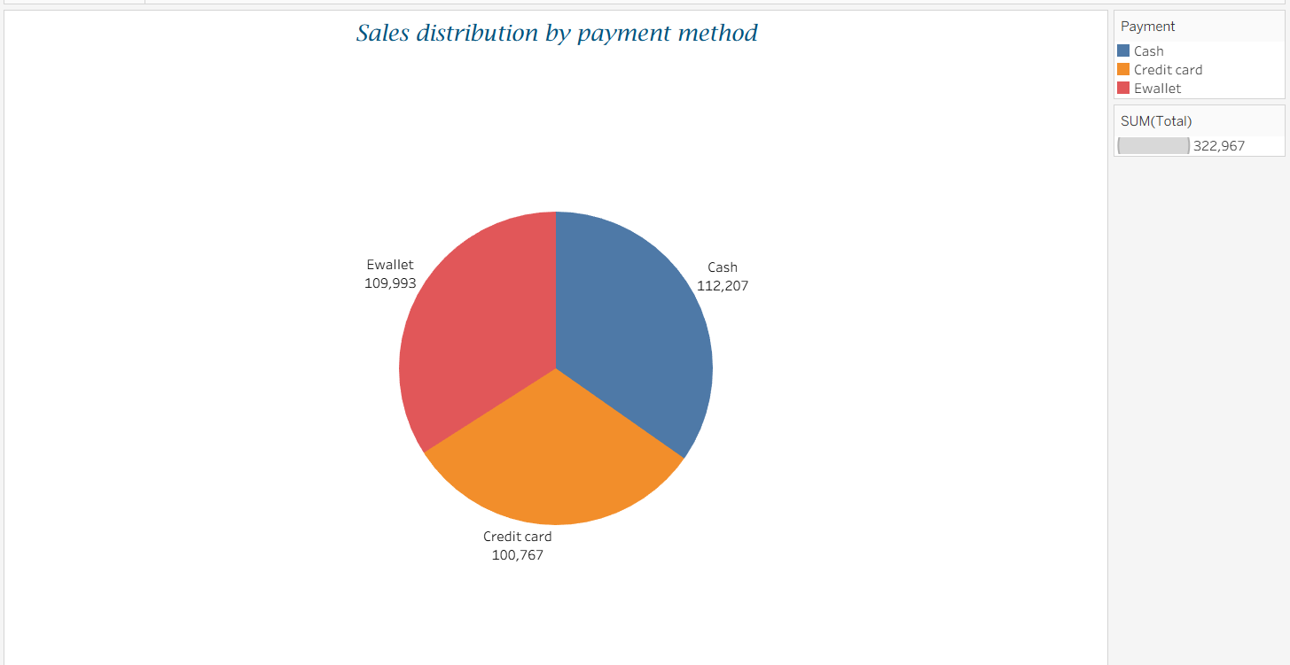

**Stacked Bar Chart:**

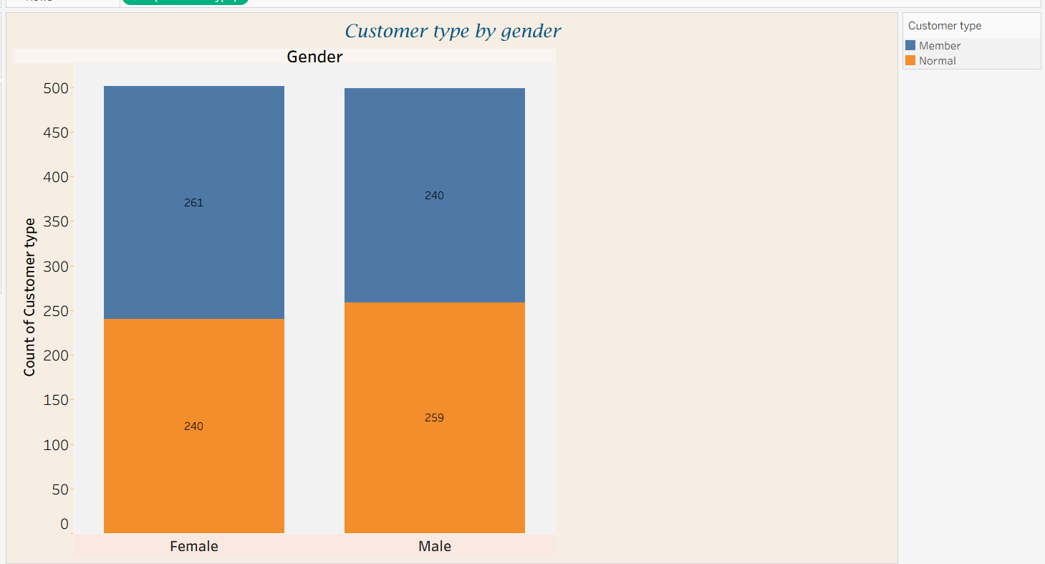

**Line Chart-Monthly Sales Trend**

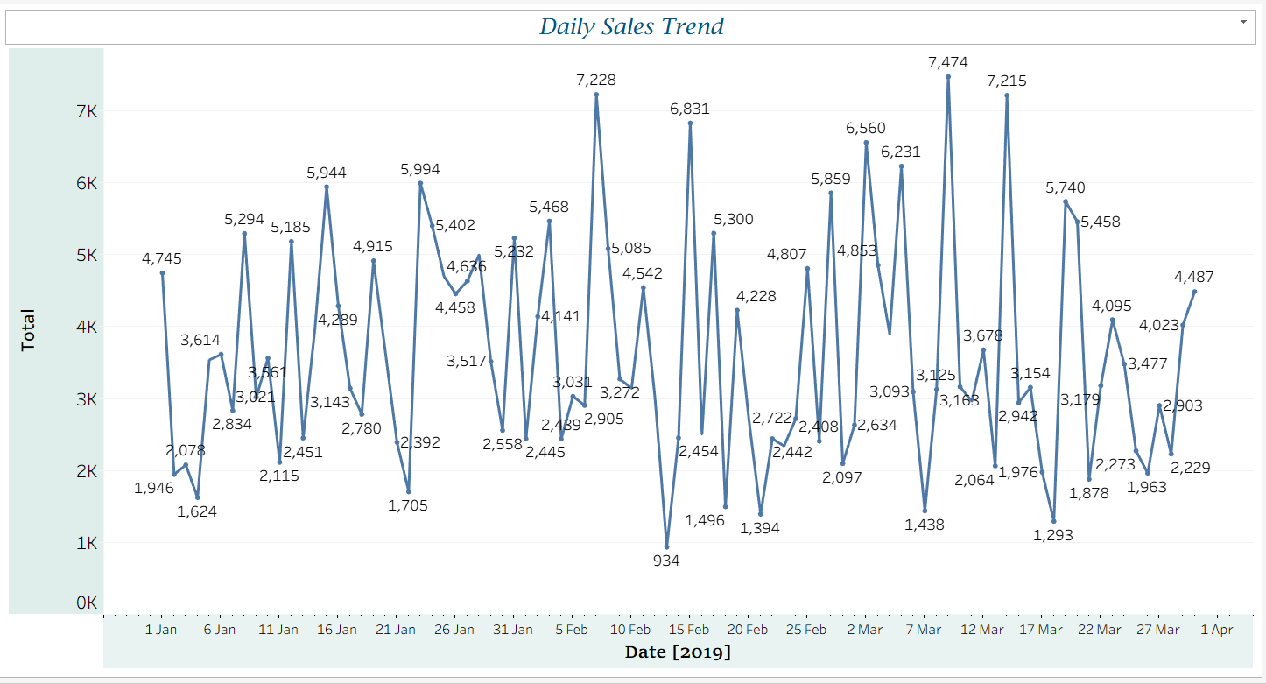

**Bubble Chart**

